**Supplementary contents the paper: “An approach for selecting a model for the assessment of potentially contaminated sites.”**

1. **Complementary plots for Fig. 1 of the paper**

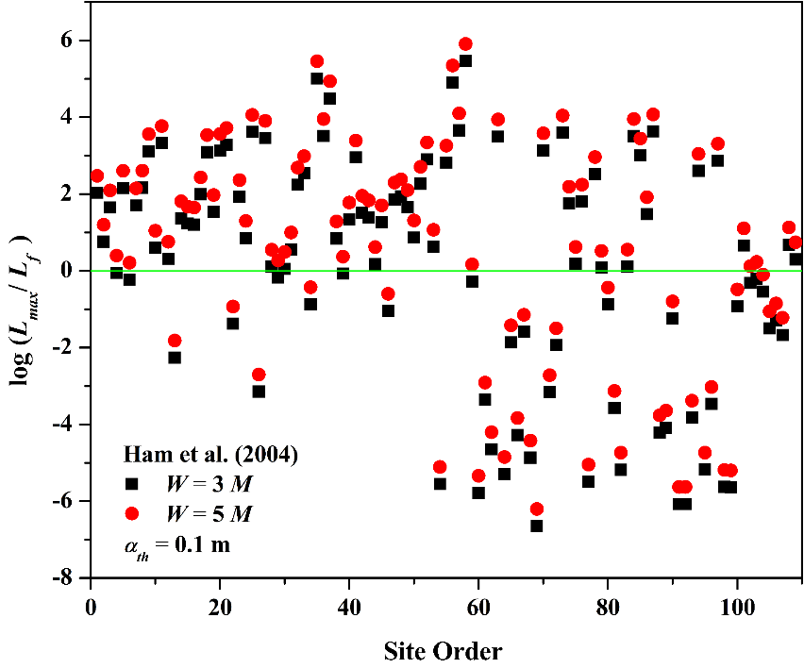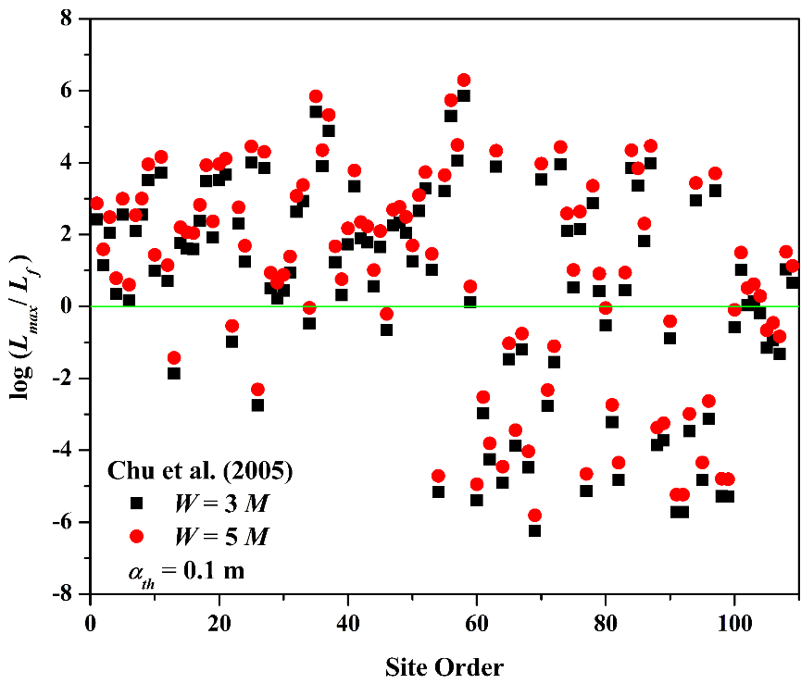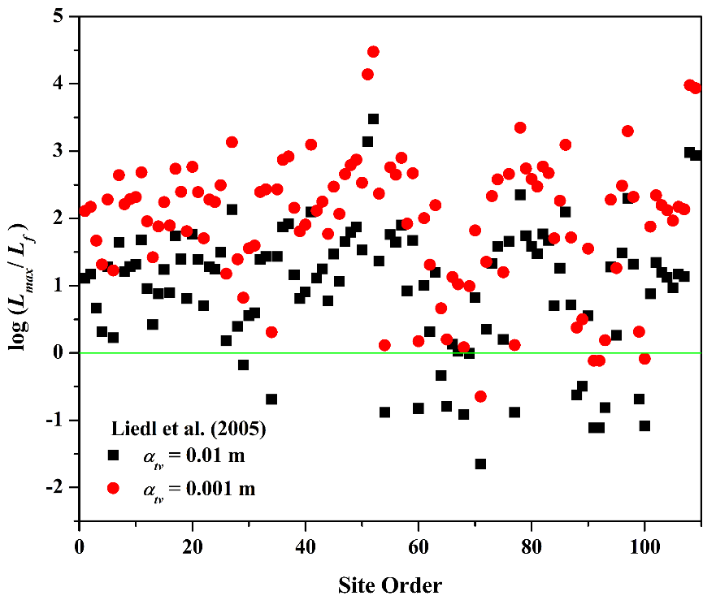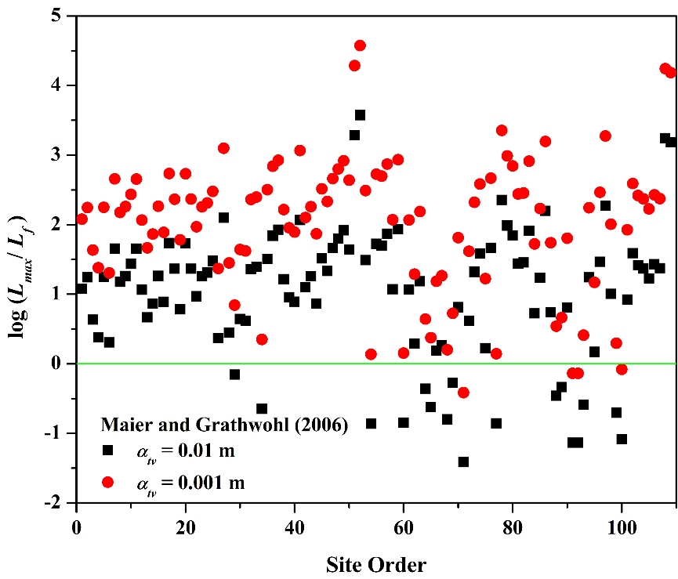

**Figure 1: Model performance to predict field 𝐿𝑚𝑎𝑥, green line indicates the overestimation limit. All points above green line are over-estimates and all point under the green line are underestimated.**

1. **Complementary plot (Q-Q) graphically showing that field plume length does not follow normal distribution.**

**Figure 2: Q-Q plot comparing normal distribution and field *𝐿𝑚𝑎𝑥.***

1. **Complementary plots for Fig. 4 of the paper**

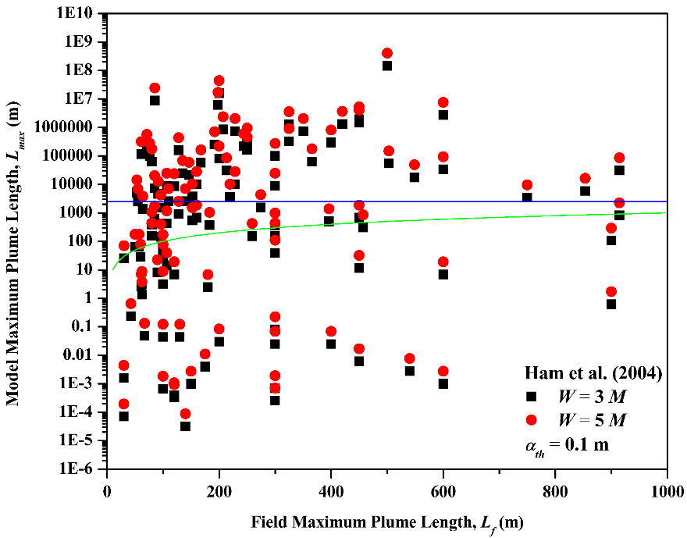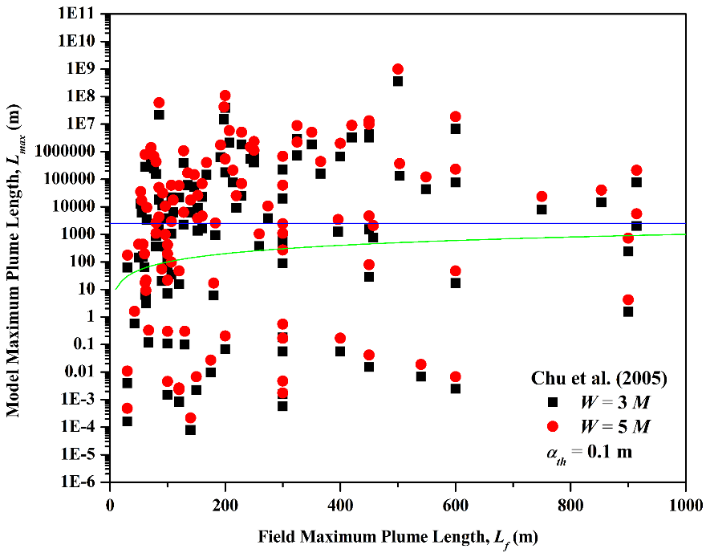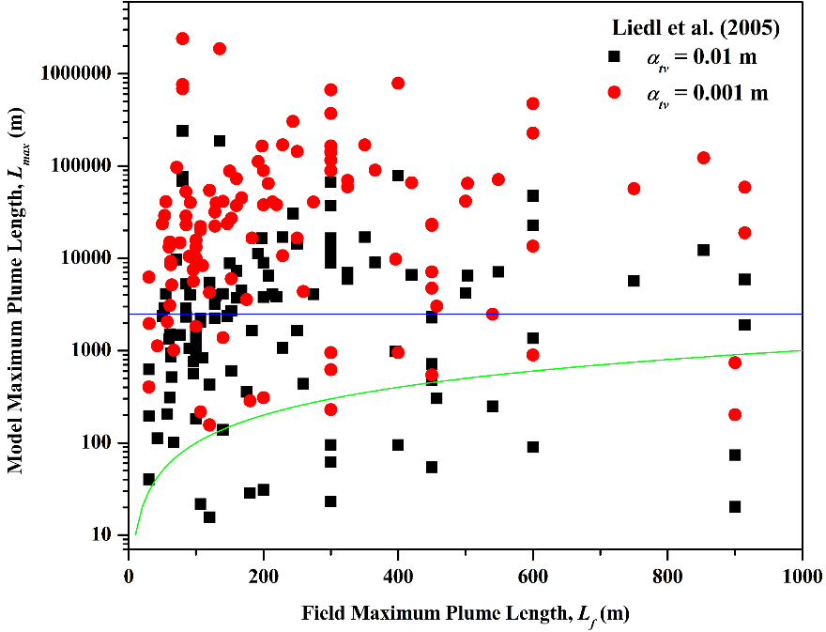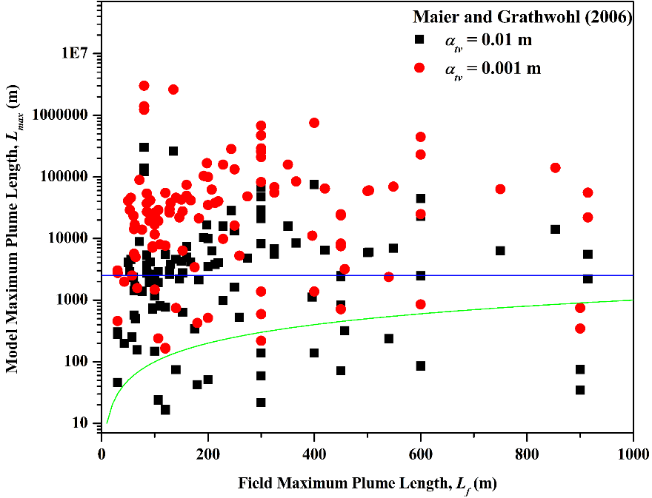

**Figure 3: Model performance to predict field 𝐿𝑚𝑎𝑥, green line indicates the overestimation limit. All points above green line are over-estimates and all point under the green line are underestimated. Blue line indicates the over-overestimation limit. All points above blue line are overly-overestimated.**

1. **Theoretical description of AHP method based on Saaty (2012)**

AHP is a multi-criteria decision method that uses hierarchy structure consisting of goal, interlinked with criteria and alternatives or options (see figure below).

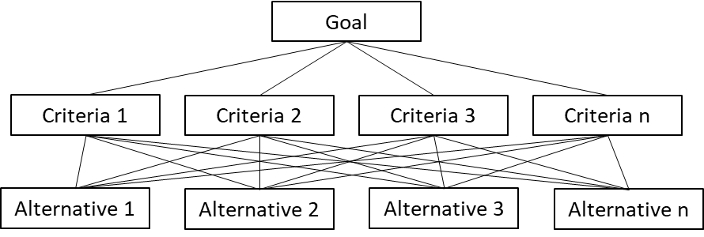

AHP follows the following computing steps:

1. **Computing the vector of criteria weights**

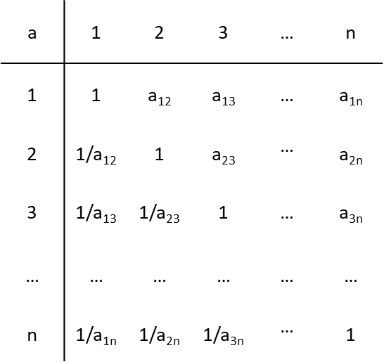Pairwise comparison matrix **A** (*m* x *m*) is created for computing the weights for the different (*m*) criteria. The elements of matrix are qualitative but expressed numerically based on Saaty’s relative importance scale (1 – 9, with 9 being the highest importance), i.e., the element *aij* of matrix represents the importance of *i*th criterion relative to the *j*th criterion. Ensuring that Transitivity (*aij = aji*) and reciprocity (*aij* =1/ *aji)*) rules are followed makes the developed matrix consistent. The reciprocity leads to *aii* =1 in **A**.

**A *=***

Normalized matrix (**A***norm*) is obtained by transforming each element of **A** by: , and finally, the criteria weight vector (*w)* is obtained by averaging the entries on each row of **A***norm*, i.e,: . This is equivalent to obtaining the principal eigenvector.

1. **Computing the matrix of option scores**

Option scores are vectors ***s***(j), with *j* = 1,…,*m*, are computed using the same approach that is used for obtaining the criteria weight vector (*w*). The score matrix is then obtained as

Where *j*th column of **S** corresponds to ***s***(*j*).

1. **Obtaining the ranking of the options**

The ranking of the options the vector *R* is obtained from:

Where the *i*th entry *Ri*of R represents the rank of the *i*th option.

The development of pairwise matrix can led to inconsistency, which can be checked using eq. (6) in the MS. In case of inconsistency, the weight ma matrices have to be re-developed as described in point (i).

The computation steps used in the MS for the computation of R can be found at <https://github.com/prabhasyadav/MS_Decision>

**5. Comparison and pair-wise matrices used is Section 3.3.1 (AHP)**

1. **High reliability case:**

*Criteria Comparison Matrix:*

|  |  |  |  |  |
| --- | --- | --- | --- | --- |
|  | Underestimation | Ov.Overestimation | Goodness of fit | Model Complexity |
| Underestimation | 1 | 5 | 3 | 7 |
| Ov. Overestimation | 1/5 | 1 | 1/3 | 3 |
| Goodness of fit | 1/3 | 3 | 1 | 5 |
| Model Complexity | 1/7 | 1/3 | 1/5 | 1 |

*Pair-wise comparison matrices:*

|  |  |  |  |  |  |
| --- | --- | --- | --- | --- | --- |
| %Nue | Underestimation | **Liedl et. al** | **Maier & Grathwohl** | **Ham et. al** | **Chu et. al** |
| 7.3 | **Liedl et. al** | 1 | 1/3 | 7 | 6 |
| 4.6 | **Maier & Grathwohl** | 3 | 1 | 8 | 7 |
| 33 | **Ham et. al** | 1/7 | 1/8 | 1 | 1/2 |
| 31.2 | **Chu et. al** | 1/6 | 1/7 | 2 | 1 |

|  |  |  |  |  |  |
| --- | --- | --- | --- | --- | --- |
| % Nooe | Ov. Overestimate | **Liedl et. al** | **Maier & Grathwohl** | **Ham et. al** | **Chu et. al** |
| 89.9 | **Liedl et. al** | 1 | 1 | 1/6 | 1/5 |
| 90.8 | **Maier & Grathwohl** | 1 | 1 | 1/6 | 1/6 |
| 62.4 | **Ham et. al** | 6 | 6 | 1 | 2 |
| 66.1 | **Chu et. al** | 5 | 6 | 1/2 | 1 |

|  |  |  |  |  |  |
| --- | --- | --- | --- | --- | --- |
| Nln(SSE/N) | Goodness of fit | **Liedl et. al** | **Maier & Grathwohl** | **Ham et. al** | **Chu et. al** |
| 415 | **Liedl et. al** | 1 | 2 | 7 | 9 |
| 421 | **Maier & Grathwohl** | 1/2 | 1 | 6 | 8 |
| 495 | **Ham et. al** | 1/7 | 1/6 | 1 | 3 |
| 514 | **Chu et. al** | 1/9 | 1/8 | 1/3 | 1 |

|  |  |  |  |  |
| --- | --- | --- | --- | --- |
| Model Comp. | **Liedl et. al** | **Maier & Grathwohl** | **Ham et. al** | **Chu et. al** |
| **Liedl et. al** | 1 | 1 | 1/5 | 5 |
| **Maier & Grathwohl** | 1 | 1 | 1/5 | 5 |
| **Ham et. al** | 5 | 5 | 1 | 9 |
| **Chu et. al** | 1/5 | 1/5 | 1/9 | 1 |

1. **Reliable lower bound case:**

*Criteria Comparison Matrix:*

|  |  |  |  |  |
| --- | --- | --- | --- | --- |
|  | **Underestimation** | **Ov. Overestimation** | **Goodness of fit** | **Model Complexity** |
| **Underestimation** | **1** | **4** | **3** | **7** |
| **Ov. Overestimation** | **1/4** | **1** | **1/3** | **3** |
| **Goodness of fit** | **1/3** | **3** | **1** | **5** |
| **Model Complexity** | **1/7** | **1/3** | **1/5** | **1** |

*Pair-wise comparison matrices:*

|  |  |  |  |  |  |
| --- | --- | --- | --- | --- | --- |
| **%Nue** | **Underestimation** | **Liedl et. al** | **Maier & Grathwohl** | **Ham et. al** | **Chu et. al** |
| **2.8** | **Liedl et. al** | **1** | **1** | **6** | **7** |
| **2.8** | **Maier & Grathwohl** | **1** | **1** | **6** | **7** |
| **29.4** | **Ham et. al** | **1/6** | **1/6** | **1** | **2** |
| **27.5** | **Chu et. al** | **1/7** | **1/7** | **1/2** | **1** |

|  |  |  |  |  |  |
| --- | --- | --- | --- | --- | --- |
| % Nooe | **Ov. Overestimation** | **Liedl et. al** | **Maier & Grathwohl** | **Ham et. al** | **Chu et. al** |
| 90.8 | **Liedl et. al** | 1 | 1 | 1/6 | 1/5 |
| 91.7 | **Maier & Grathwohl** | 1 | 1 | 1/6 | 1/6 |
| 63.3 | **Ham et. al** | 6 | 6 | 1 | 2 |
| 68.8 | **Chu et. al** | 5 | 6 | 1/2 | 1 |

|  |  |  |  |  |  |
| --- | --- | --- | --- | --- | --- |
| Nln(SSE/N) | Goodness of fit | **Liedl et. al** | **Maier & Grathwohl** | **Ham et. al** | **Chu et. al** |
| 440 | **Liedl et. al** | 1 | 2 | 7 | 9 |
| 446 | **Maier & Grathwohl** | 1/2 | 1 | 6 | 8 |
| 516 | **Ham et. al** | 1/7 | 1/6 | 1 | 3 |
| 537 | **Chu et. al** | 1/9 | 1/8 | 1/3 | 1 |

|  |  |  |  |  |
| --- | --- | --- | --- | --- |
| Model Complexity | **Liedl et. al** | **Maier & Grathwohl** | **Ham et. al** | **Chu et. al** |
| **Liedl et. al** | 1 | 1 | 1/5 | 5 |
| **Maier & Grathwohl** | 1 | 1 | 1/5 | 5 |
| **Ham et. al** | 5 | 5 | 1 | 9 |
| **Chu et. al** | 1/5 | 1/5 | 1/9 | 1 |

1. **Reliable upper bound case:**

*Criteria Comparison Matrix:*

|  |  |  |  |  |
| --- | --- | --- | --- | --- |
|  | **Underestimation** | **Ov. Overestimation** | **Goodness of fit** | **Model Complexity** |
| **Underestimation** | 1 | 6 | 3 | 7 |
| **Ov. Overestimation** | 1/6 | 1 | 1/3 | 3 |
| **Goodness of fit** | 1/3 | 3 | 1 | 5 |
| **Model Complexity** | 1/7 | 1/3 | 1/5 | 1 |

*Pair-wise comparison matrices:*

|  |  |  |  |  |  |
| --- | --- | --- | --- | --- | --- |
| %Nue | Underestimation | **Liedl et. al** | **Maier & Grathwohl** | **Ham et. al** | **Chu et. al** |
| 12.8 | **Liedl et. al** | 1 | 1/2 | 7 | 6 |
| 11 | **Maier & Grathwohl** | 2 | 1 | 7 | 6 |
| 37.6 | **Ham et. al** | 1/7 | 1/7 | 1 | 1/2 |
| 33 | **Chu et. al** | 1/6 | 1/6 | 2 | 1 |

|  |  |  |  |  |  |
| --- | --- | --- | --- | --- | --- |
| % Nooe | Ov. Overest. | **Liedl et. al** | **Maier & Grathwohl** | **Ham et. al** | **Chu et. al** |
| 83.5 | **Liedl et. al** | 1 | 1 | 1/6 | 1/5 |
| 83.5 | **Maier & Grathwohl** | 1 | 1 | 1/6 | 1/5 |
| 55 | **Ham et. al** | 6 | 6 | 1 | 2 |
| 58.7 | **Chu et. al** | 5 | 5 | 1/2 | 1 |

|  |  |  |  |  |  |
| --- | --- | --- | --- | --- | --- |
| Nln(SSE/N) | Goodness of fit | **Liedl et. al** | **Maier & Grathwohl** | **Ham et. al** | **Chu et. al** |
| 386 | **Liedl et. al** | 1 | 2 | 7 | 9 |
| 393 | **Maier & Grathwohl** | 1/2 | 1 | 6 | 8 |
| 479 | **Ham et. al** | 1/7 | 1/6 | 1 | 3 |
| 497 | **Chu et. al** | 1/9 | 1/8 | 1/3 | 1 |

|  |  |  |  |  |
| --- | --- | --- | --- | --- |
| Model Comp. | **Liedl et. al** | **Maier & Grathwohl** | **Ham et. al** | **Chu et. al** |
| **Liedl et. al** | 1 | 1 | 1/5 | 5 |
| **Maier & Grathwohl** | 1 | 1 | 1/5 | 5 |
| **Ham et. al** | 5 | 5 | 1 | 9 |
| **Chu et. al** | 1/5 | 1/5 | 1/9 | 1 |

1. **Moderate Reliable- lower bound case:**

*Criteria Comparison Matrix:*

|  |  |  |  |  |
| --- | --- | --- | --- | --- |
|  | ***Underestimation*** | ***Ov. Overestimation*** | ***Goodness of fit*** | ***Model Complexity*** |
| ***Underestimation*** | *1* | *2* | *2* | *6* |
| ***Ov. Overestimation*** | *1/2* | *1* | *1/2* | *4* |
| ***Goodness of fit*** | *1/2* | *2* | *1* | *5* |
| ***Model Complexity*** | *1/6* | *1/4* | *1/5* | *1* |

*Pair-wise comparison matrices:*

|  |  |  |  |  |  |
| --- | --- | --- | --- | --- | --- |
| *%Nue* | *Underestimation* | ***Liedl et. al*** | ***Maier & Grathwohl*** | ***Ham et. al*** | ***Chu et. al*** |
| *0.9* | ***Liedl et. al*** | *1* | *1* | *8* | *7* |
| *0* | ***Maier & Grathwohl*** | *1* | *1* | *8* | *7* |
| *26.6* | ***Ham et. al*** | *1/8* | *1/8* | *1* | *1/2* |
| *22.9* | ***Chu et. al*** | *1/7* | *1/7* | *2* | *1* |

|  |  |  |  |  |  |
| --- | --- | --- | --- | --- | --- |
| *% Nooe* | *Ov. Overest.* | ***Liedl et. al*** | ***Maier & Grathwohl*** | ***Ham et. al*** | ***Chu et. al*** |
| *92.7* | ***Liedl et. al*** | *1* | *2* | *1/6* | *1/5* |
| *95.4* | ***Maier & Grathwohl*** | *1/2* | *1* | *1/7* | *1/6* |
| *67* | ***Ham et. al*** | *6* | *7* | *1* | *2* |
| *70.6* | ***Chu et. al*** | *5* | *6* | *1/2* | *1* |

|  |  |  |  |  |  |
| --- | --- | --- | --- | --- | --- |
| *Nln(SSE/N)* | *Goodness of fit* | ***Liedl et. al*** | ***Maier & Grathwohl*** | ***Ham et. al*** | ***Chu et. al*** |
| *477* | ***Liedl et. al*** | *1* | *2* | *7* | *9* |
| *482* | ***Maier & Grathwohl*** | *1/2* | *1* | *6* | *8* |
| *539* | ***Ham et. al*** | *1/7* | *1/6* | *1* | *3* |
| *560* | ***Chu et. al*** | *1/9* | *1/8* | *1/3* | *1* |

|  |  |  |  |  |
| --- | --- | --- | --- | --- |
| *Model Comp.* | ***Liedl et. al*** | ***Maier & Grathwohl*** | ***Ham et. al*** | ***Chu et. al*** |
| ***Liedl et. al*** | *1* | *1* | *1/5* | *5* |
| ***Maier & Grathwohl*** | *1* | *1* | *1/5* | *5* |
| ***Ham et. al*** | *5* | *5* | *1* | *9* |
| ***Chu et. al*** | *1/5* | *1/5* | *1/9* | *1* |

1. **Moderate Reliable- upper bound case:**

*Criteria Comparison Matrix:*

|  |  |  |  |  |
| --- | --- | --- | --- | --- |
|  | ***Underestimation*** | ***Ov. Overestimation*** | ***Goodness of fit*** | ***Model Complexity*** |
| ***Underestimation*** | *1* | *7* | *4* | *8* |
| ***Ov. Overestimation*** | *1/7* | *1* | *1/4* | *4* |
| ***Goodness of fit*** | *1/4* | *4* | *1* | *5* |
| ***Model Complexity*** | *1/8* | *1/4* | *1/5* | *1* |

*Pair-wise comparison matrices:*

|  |  |  |  |  |  |
| --- | --- | --- | --- | --- | --- |
| *%Nue* | *Underestimation* | ***Liedl et. al*** | ***Maier & Grathwohl*** | ***Ham et. al*** | ***Chu et. al*** |
| *16.5* | ***Liedl et. al*** | *1* | *1* | *8* | *7* |
| *15.9* | ***Maier & Grathwohl*** | *1* | *1* | *8* | *7* |
| *46.8* | ***Ham et. al*** | *1/8* | *1/8* | *1* | *1/2* |
| *41.3* | ***Chu et. al*** | *1/7* | *1/7* | *2* | *1* |

|  |  |  |  |  |  |
| --- | --- | --- | --- | --- | --- |
| *% Nooe* | *Ov. Overest.* | ***Liedl et. al*** | ***Maier & Grathwohl*** | ***Ham et. al*** | ***Chu et. al*** |
| *67* | ***Liedl et. al*** | *1* | *1* | *1/6* | *1/5* |
| *67.9* | ***Maier & Grathwohl*** | *1* | *1* | *1/6* | *1/5* |
| *45* | ***Ham et. al*** | *6* | *6* | *1* | *2* |
| *48.6* | ***Chu et. al*** | *5* | *5* | *1/2* | *1* |

|  |  |  |  |  |  |
| --- | --- | --- | --- | --- | --- |
| *Nln(SSE/N)* | *Goodness of fit* | ***Liedl et. al*** | ***Maier & Grathwohl*** | ***Ham et. al*** | ***Chu et. al*** |
| *313* | ***Liedl et. al*** | *1* | *2* | *7* | *9* |
| *321* | ***Maier & Grathwohl*** | *1/2* | *1* | *6* | *8* |
| *457* | ***Ham et. al*** | *1/7* | *1/6* | *1* | *3* |
| *470* | ***Chu et. al*** | *1/9* | *1/8* | *1/3* | *1* |

|  |  |  |  |  |
| --- | --- | --- | --- | --- |
| *Model Comp.* | ***Liedl et. al*** | ***Maier & Grathwohl*** | ***Ham et. al*** | ***Chu et. al*** |
| ***Liedl et. al*** | *1* | *1* | *1/5* | *5* |
| ***Maier & Grathwohl*** | *1* | *1* | *1/5* | *5* |
| ***Ham et. al*** | *5* | *5* | *1* | *9* |
| ***Chu et. al*** | *1/5* | *1/5* | *1/9* | *1* |



**Figure 4: Defining the alternative sum of squared errors based on the equivalent line.**